Bangladesh University of Textiles
Department of Textile Engineering Management
No. of Experiment: 02
Screening of Ring-Spinning Process Parameters Affecting Yarn Hairiness Index Using a Plackett–Burman Design (Minitab)

Submitted by: Md. Ariful Islam
ID: 23010501077

Course code and title: Textile Process Optimization Lab (TEM 310-0413)

Submitted to: Prof. Dr. Md. Syduzzaman
Department of Textile Engineering Management,Butex
Date of Experiment: September 06, 2026
Date of Submission: September 13, 2026

1. Objective
The primary objective of this experiment is to screen six candidate ring-spinning process parameters and identify, with the minimum possible number of trials, which of them have a statistically and practically significant effect on yarn Hairiness Index, using a Plackett–Burman screening Design of Experiments (DoE) in Minitab. Specifically, this study aims to:
- Evaluate the individual (main) effect of Spindle Speed, Spinning Tension, Traveler Weight, Ring Diameter, Yarn Count, and Twist Multiplier on yarn hairiness using a 12-run Plackett–Burman design.
- Rank the six factors by their standardized effect on hairiness using Pareto charts and formal hypothesis tests (ANOVA / t-tests), for all three replicate readings (H1, H2, H3).
- Separate the 'vital few' factors that materially affect hairiness from the 'trivial many' that can be fixed at any convenient level.
- Recommend a focused, higher-resolution follow-up experiment (optimization stage) on only the factors found to be influential, so that experimental effort is not wasted on unimportant variables.

2. Theory / Background
Hairiness is one of the most important yarn-quality attributes for ring-spun yarn: protruding fibres reduce fabric appearance, increase pilling and end-breaks in downstream processes, and can indicate excessive fibre damage or poor spinning-zone control. Because hairiness is influenced by many machine settings, standard practice is to first run a screening experiment that quickly identifies which of the many candidate parameters actually matter, before committing to an expensive optimization study.

2.1 Screening Designs
A screening design is a DoE strategy used early in an investigation, when many factors (here, six) are suspected of influencing a response but resources do not permit a full 2⁶ = 64-run factorial study. Screening designs sacrifice some information — mainly the ability to cleanly separate two-factor interactions from main effects — in exchange for a large reduction in the number of runs, following the Pareto principle that typically only a few of many candidate factors turn out to be practically important.

2.2 Plackett–Burman Design
The Plackett–Burman (PB) design is a two-level, Resolution III fractional factorial screening design, constructed so that runs are always a multiple of 4. For 6 factors, Minitab uses the standard 12-run PB array, giving (12 − 6 − 1) = 5 residual degrees of freedom for estimating experimental error even though every factor is studied at only 2 levels. Its key properties are:
- Orthogonality: every pair of factor columns is uncorrelated, so all six main effects can be estimated independently of one another (VIF = 1.00 for every term in every model fitted).
- Resolution III: main effects are aliased (confounded) with two-factor and higher-order interactions — the price paid for using only 12 runs instead of 64.
- Efficiency: only 12 experimental runs are needed to screen 6 factors, versus 64 runs for a full 2⁶ factorial — a reduction of over 80% in experimental effort.

2.3 Pareto Chart of Standardized Effects
Once the linear (main-effects) model is fitted, Minitab's Pareto Chart of Standardized Effects ranks the six factors by the absolute value of their standardized effect (t-statistic). A reference line, from Lenth's pseudo-standard-error method at α = 0.05, is superimposed: bars that cross this line are candidates for statistically significant effects, while bars that fall short are not distinguishable from noise.

3. Process Parameters and Levels
Six ring-spinning process parameters, believed from prior experience to potentially influence yarn hairiness, were selected for screening:
Factor | Name | Low Level | High Level | Unit
A | Spindle Speed (SS) | 12000 | 16000 | rpm
B | Spinning Tension (ST) | 10 | 22 | cN
C | Traveler Weight (TW) | 2.5 | 4.0 | mg
D | Ring Diameter (RD) | 36 | 42 | mm
E | Yarn Count (YC) | 20 | 40 | Ne
F | Twist Multiplier (F) | 3.5 | 4.5 | -
Note: while setting up the Create Screening Design > Factors dialog in Minitab, the Spindle Speed low level was initially mistyped as 120000 rpm. This was identified and corrected to 12000 rpm before the design was generated, giving the valid 12000–16000 rpm range shown above and in Figure 3.

3.1 Response (Output) Parameter
Yarn Hairiness Index (H): a smaller-the-better response, since fewer protruding fibres indicate a smoother, higher-quality yarn. Three replicate hairiness readings (H1, H2, H3) were recorded for each of the 12 trials and analysed independently, so that both the factor effects and the run-to-run variability could be studied.

4. Process Flow
- Step 1 — Select the 6 candidate process factors and a low/high level for each.
- Step 2 — Open Minitab: Stat > DOE > Screening > Create Screening Design.
- Step 3 — Select design type: Plackett–Burman, Number of factors = 6.
- Step 4 — Enter factor names and low/high levels in the Factors dialog (correcting the Spindle Speed typo).
- Step 5 — Minitab generates the 12-run Plackett–Burman design worksheet.
- Step 6 — Spin 12 trial bobbins at the specified settings; measure Hairiness Index in triplicate (H1, H2, H3).
- Step 7 — Enter the H1, H2 and H3 readings into the worksheet.
- Step 8 — Stat > DOE > Screening > Analyze Screening Design → fit a linear (main-effects) model for each response.
- Step 9 — Examine Coded Coefficients, Model Summary, ANOVA, Regression Equation and Alias Structure for H1, H2 and H3.
- Step 10 — Rank factor influence with the Pareto Chart of Standardized Effects (Lenth cutoff, α = 0.05) for each replicate.
- Step 11 — Compare the three replicates and identify the recurring 'vital few' factors.
- Step 12 — Recommend a focused follow-up design (full factorial / RSM / Taguchi) on the significant factors.

4.1 Minitab Session — Design Generation Screenshots
Steps 2–3: the screening design tool was invoked via Stat > DOE > Screening > Create Screening Design.
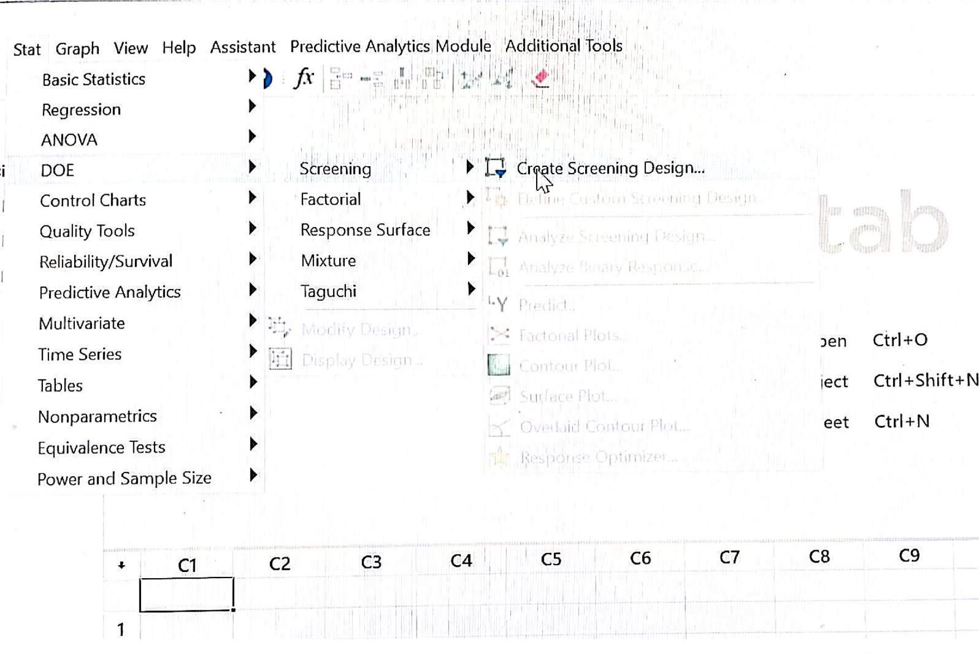
Figure 1: Stat > DOE > Screening > Create Screening Design menu path
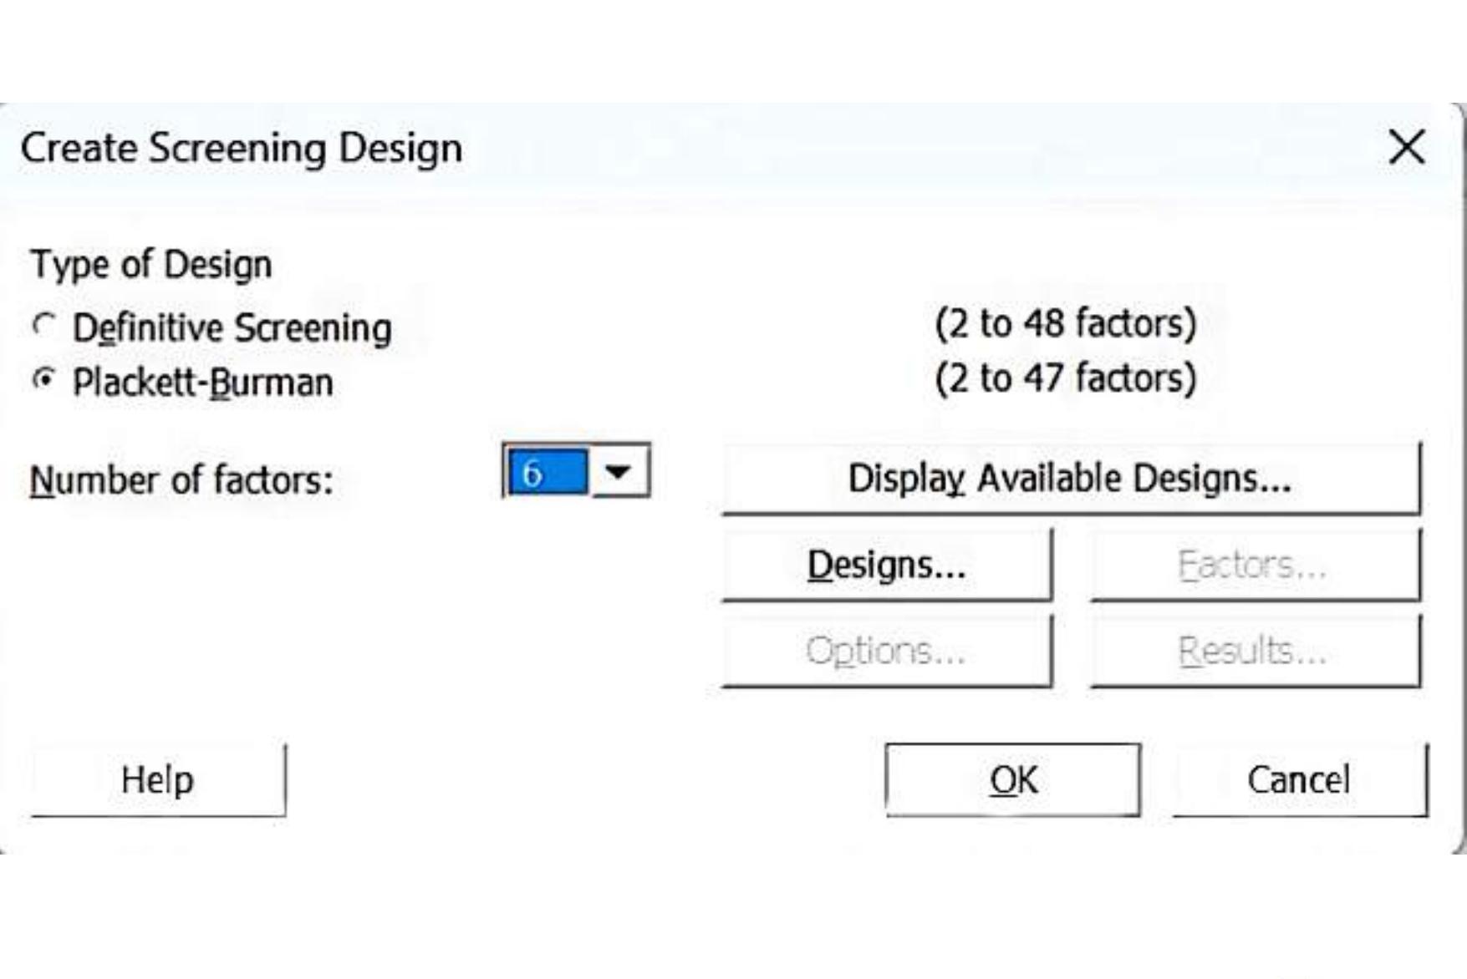
Figure 2: Create Screening Design dialog — Plackett-Burman, 6 factors
Step 4: factor names and level values entered in the Factors dialog (corrected range shown).
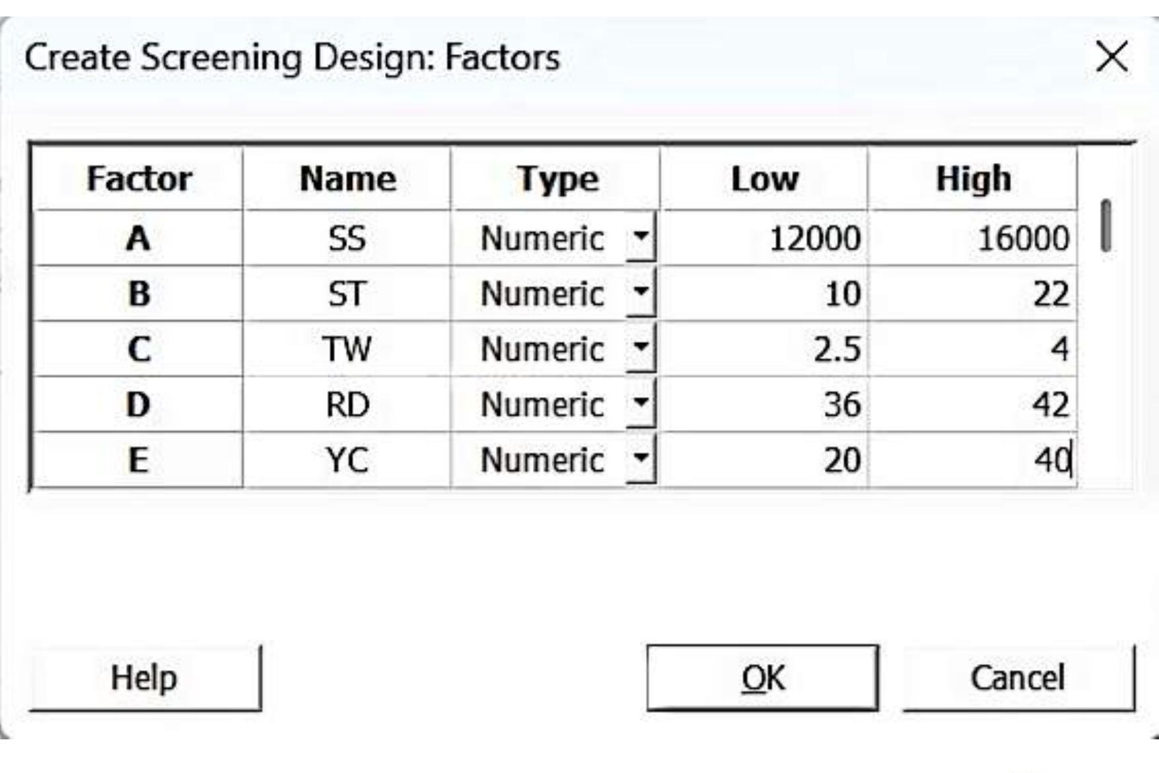
Figure 3: Create Screening Design: Factors dialog — corrected Spindle Speed range (12000–16000 rpm)
5. Experimental Design — Plackett–Burman (12-Run) Array
Step 5: Minitab generated the 12-run Plackett-Burman design worksheet shown below, giving the run order (RunOrder) and StdOrder together with the coded/uncoded factor settings.
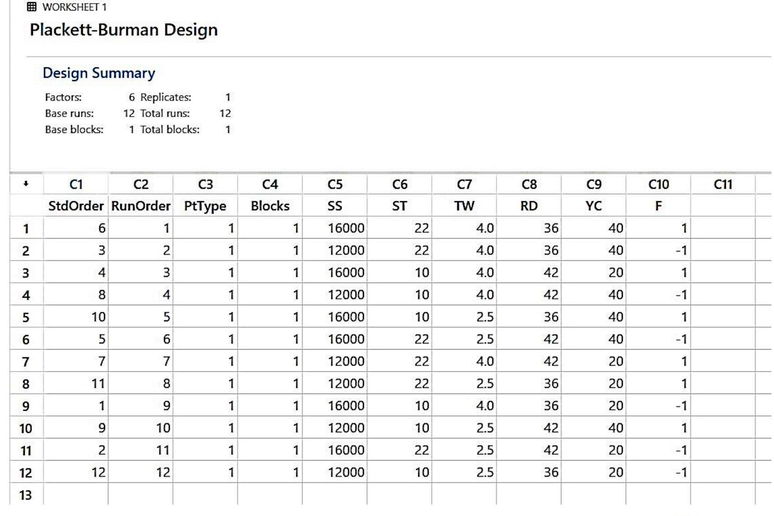
Figure 4: Minitab-generated 12-run Plackett–Burman design worksheet (StdOrder, RunOrder, SS, ST, TW, RD, YC, F)
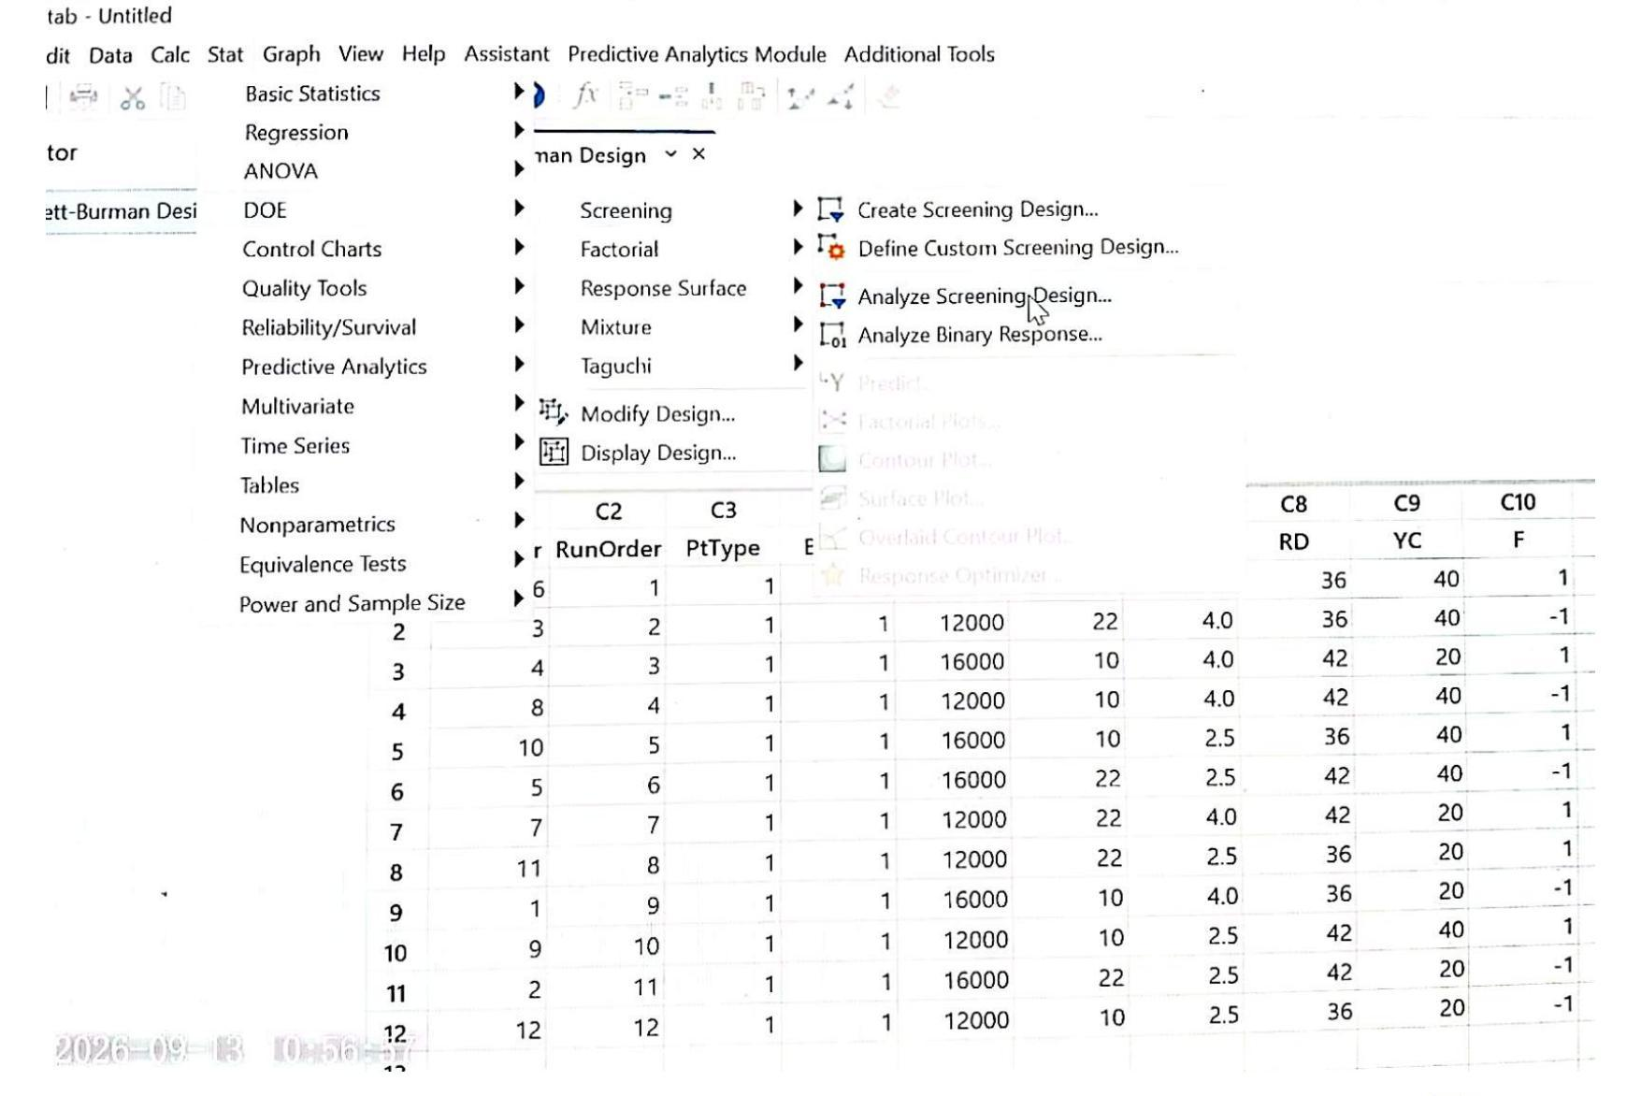
Figure 5: Stat > DOE > Screening > Analyze Screening Design, with the full design worksheet visible

6. Experimental Data / Results
Steps 6–7: three replicate Hairiness Index readings (H1, H2, H3) were recorded for each of the 12 trials, in the same worksheet row order as the design (Figure 4). H1 was the reference value supplied by the instructor; H2 and H3 were additional replicates recorded by the student.
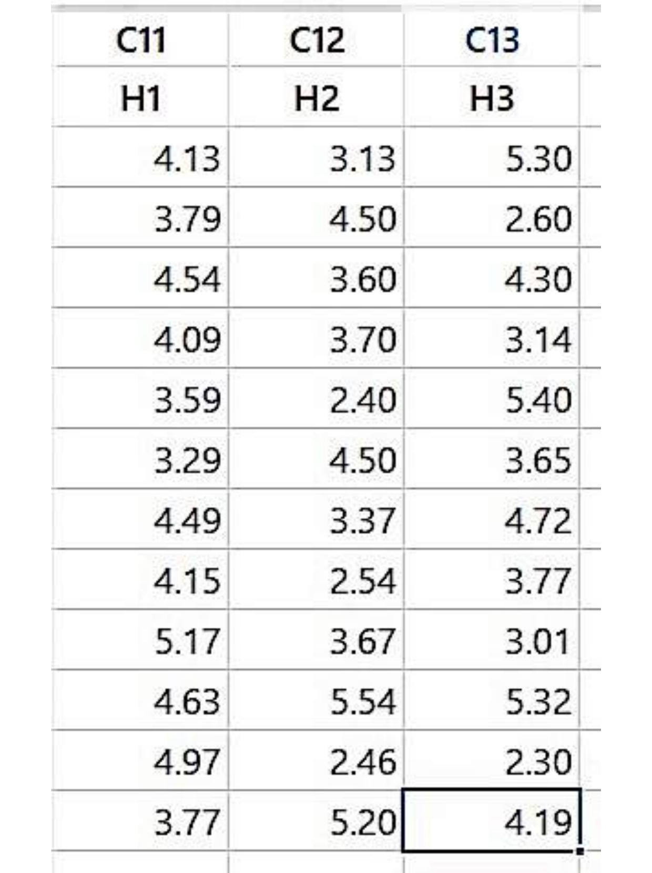
Figure 6: Hairiness Index replicate columns H1, H2, H3 as entered in the Minitab worksheet
Run | SS | ST | TW | RD | YC | F | H1 | H2 | H3 | Mean
1 | 16000 | 22 | 4.0 | 36 | 40 | 4.5 | 4.13 | 3.13 | 5.30 | 4.187
2 | 12000 | 22 | 4.0 | 36 | 40 | 3.5 | 3.79 | 4.50 | 2.60 | 3.630
3 | 16000 | 10 | 4.0 | 42 | 20 | 4.5 | 4.54 | 3.60 | 4.30 | 4.147
4 | 12000 | 10 | 4.0 | 42 | 40 | 3.5 | 4.09 | 3.70 | 3.14 | 3.643
5 | 16000 | 10 | 2.5 | 36 | 40 | 4.5 | 3.59 | 2.40 | 5.40 | 3.797
6 | 16000 | 22 | 2.5 | 42 | 40 | 3.5 | 3.29 | 4.50 | 3.65 | 3.813
7 | 12000 | 22 | 4.0 | 42 | 20 | 4.5 | 4.49 | 3.37 | 4.72 | 4.193
8 | 12000 | 22 | 2.5 | 36 | 20 | 4.5 | 4.15 | 2.54 | 3.77 | 3.487
9 | 16000 | 10 | 4.0 | 36 | 20 | 3.5 | 5.17 | 3.67 | 3.01 | 3.950
10 | 12000 | 10 | 2.5 | 42 | 40 | 4.5 | 4.63 | 5.54 | 5.32 | 5.163
11 | 16000 | 22 | 2.5 | 42 | 20 | 3.5 | 4.97 | 2.46 | 2.30 | 3.243
12 | 12000 | 10 | 2.5 | 36 | 20 | 3.5 | 3.77 | 5.20 | 4.19 | 4.387
Mean Hairiness Index ranged from 3.243 (Run 11) to 5.163 (Run 10), indicating a wide response spread suitable for screening.

7. Screening Analysis (Factorial Regression)
A linear (main-effects-only) regression model was fitted in Minitab via Stat > DOE > Screening > Analyze Screening Design, separately for each replicate (H1, H2, H3), as shown below.
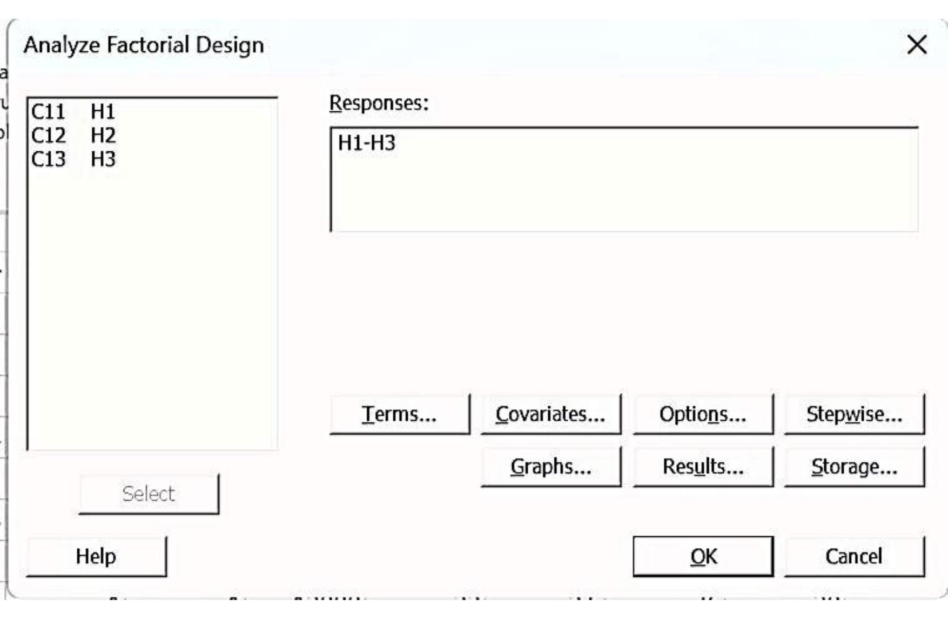
Figure 7: Analyze Factorial Design dialog — responses H1–H3 selected together

7.1 Response H1
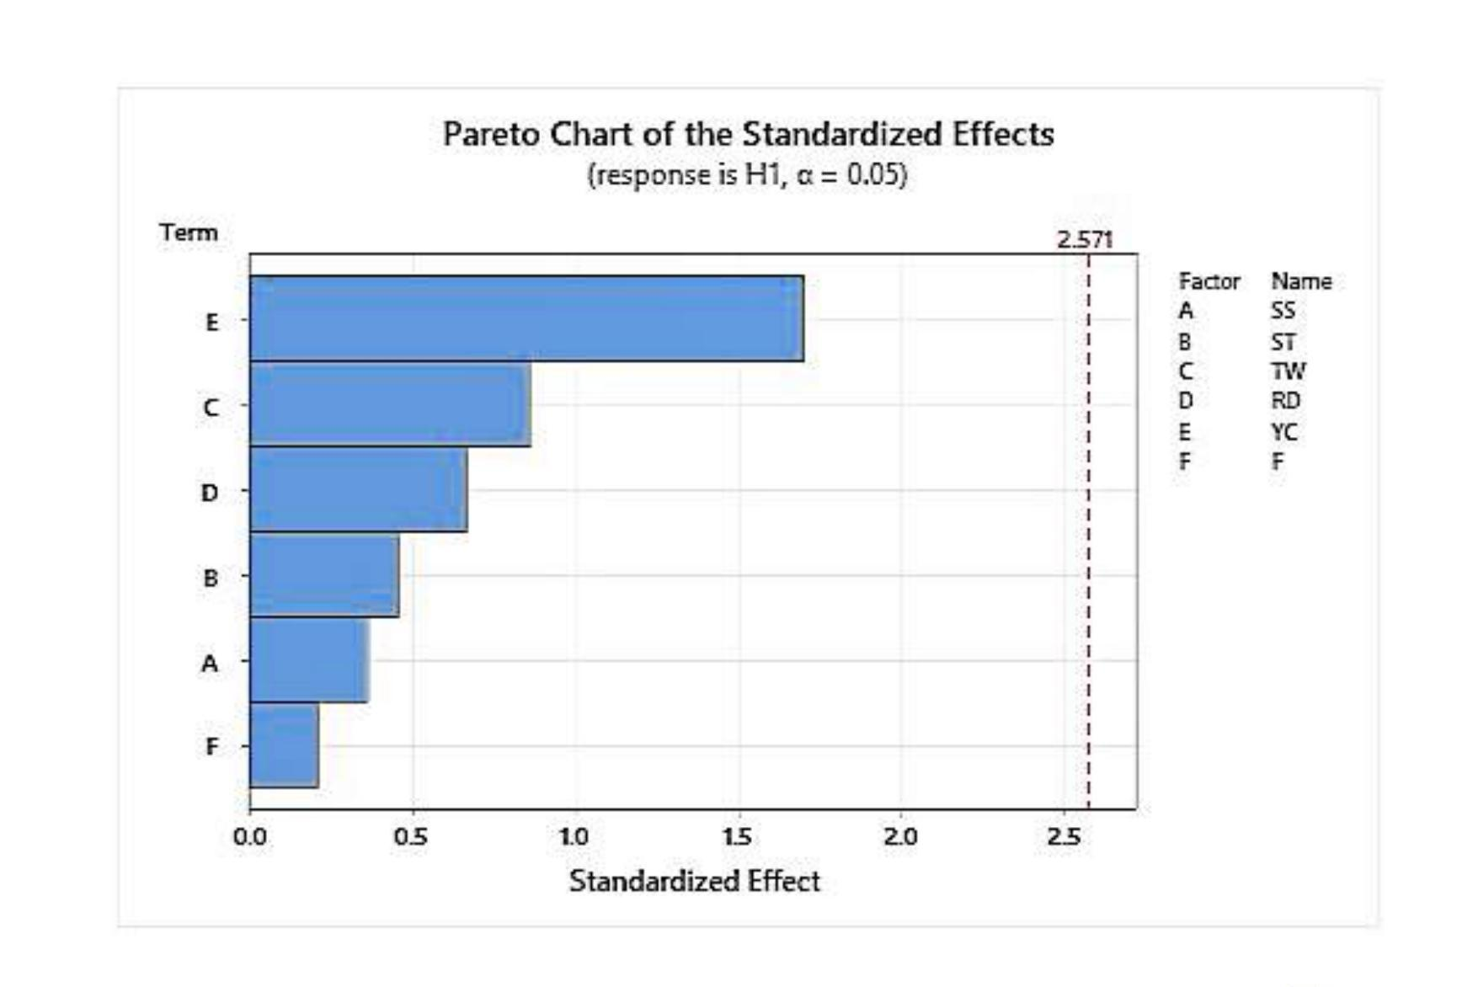
Figure 8: Pareto chart of standardized effects — response H1
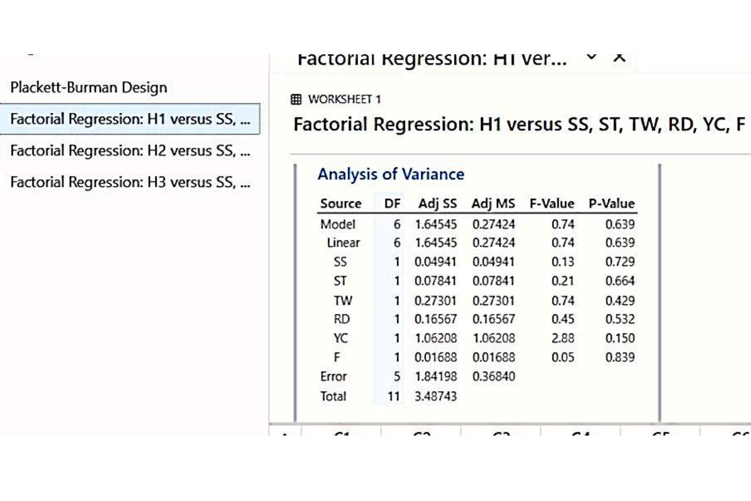
Figure 9: ANOVA for the H1 linear model
Source | DF | Adj SS | Adj MS | F-Value | P-Value
Model | 6 | 1.64545 | 0.27424 | 0.74 | 0.639
SS (A) | 1 | 0.04941 | 0.04941 | 0.13 | 0.729
ST (B) | 1 | 0.07841 | 0.07841 | 0.21 | 0.664
TW (C) | 1 | 0.27301 | 0.27301 | 0.74 | 0.429
RD (D) | 1 | 0.16567 | 0.16567 | 0.45 | 0.532
YC (E) | 1 | 1.06208 | 1.06208 | 2.88 | 0.150
F | 1 | 0.01688 | 0.01688 | 0.05 | 0.839
Error | 5 | 1.84198 | 0.36840
Total | 11 | 3.48743
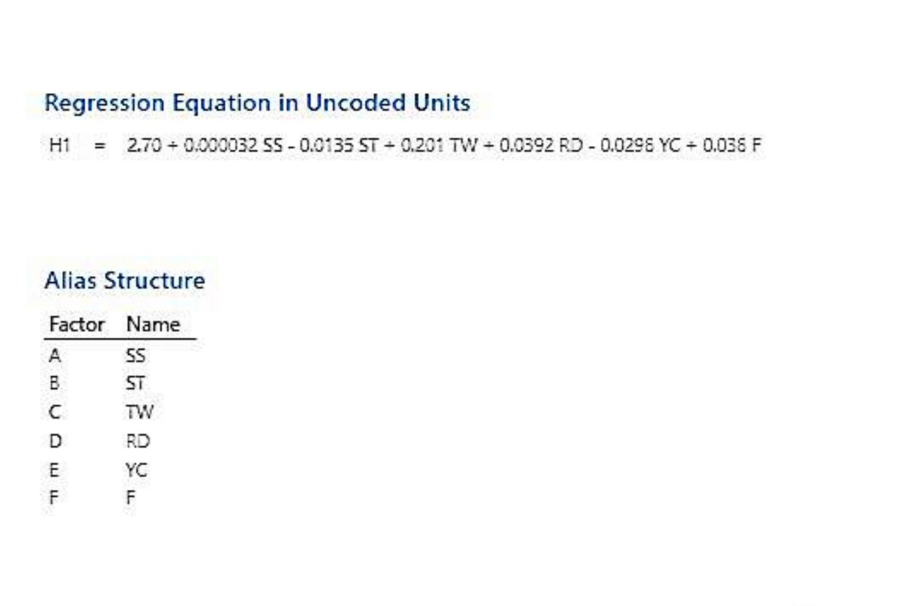
Figure 10: Regression equation (uncoded units) and alias-structure factor names — response H1
Model summary (from ANOVA): R-sq ≈ 47.2%, R-sq(adj) is effectively 0% (slightly negative), consistent with the overall model not being significant (P = 0.639). No individual factor reaches significance at α = 0.05; Yarn Count (E) has the lowest P-value (0.150) and the largest share of explained variation, making it the most influential — though inconclusive — factor for this replicate.

7.2 Response H2
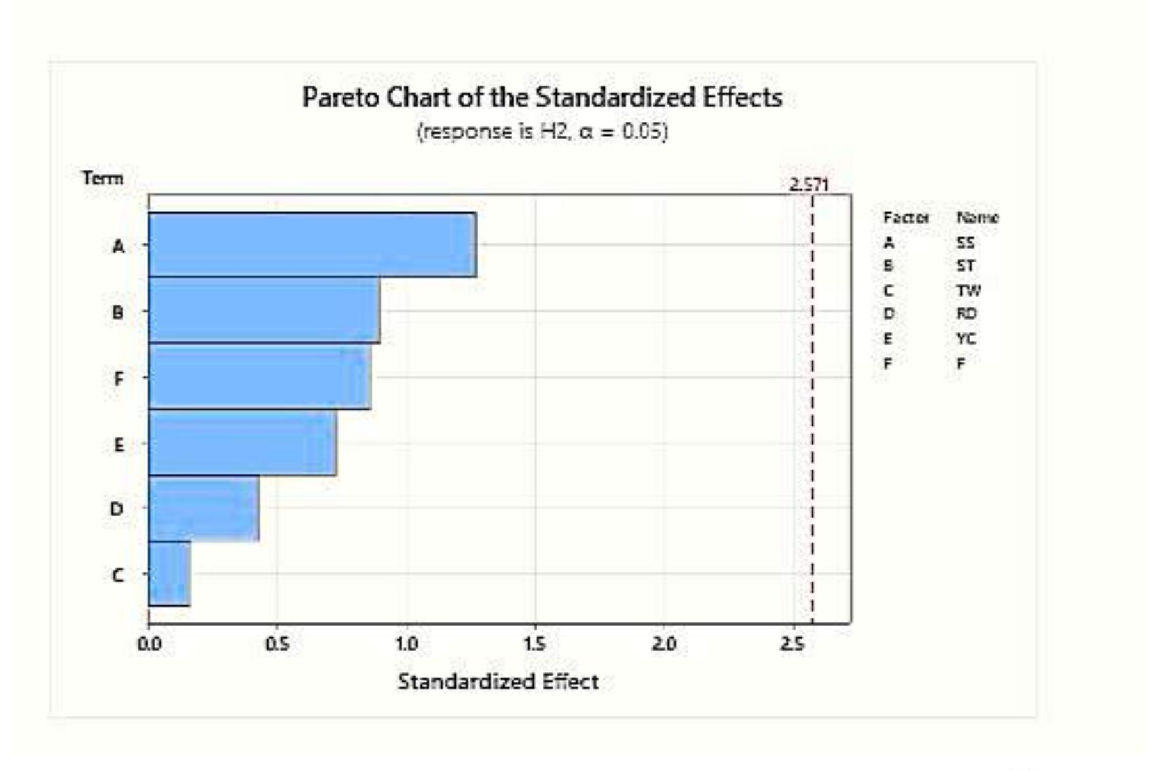
Figure 11: Pareto chart of standardized effects — response H2
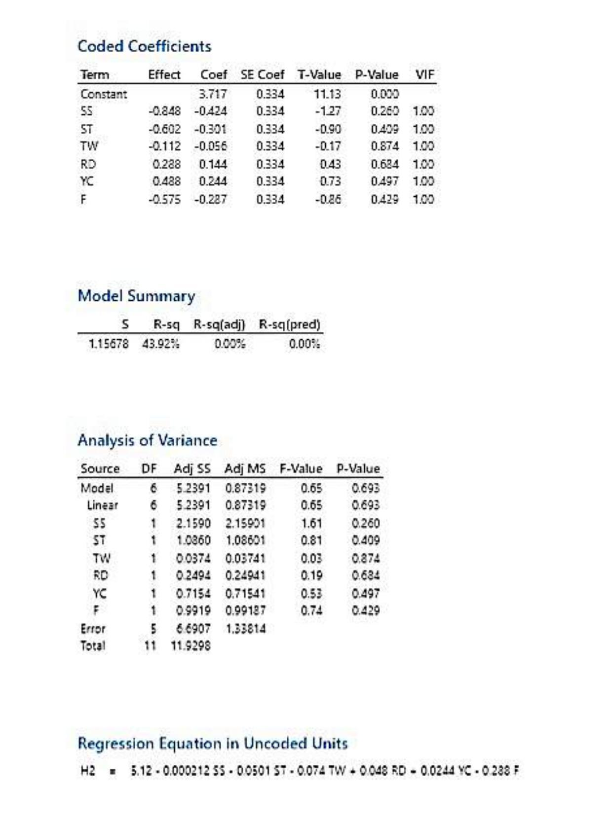
Figure 12: Coded Coefficients, Model Summary, ANOVA and Regression Equation — response H2
Model summary: S = 1.157, R-sq = 43.9%, R-sq(adj) = 0.00% — the model is not significant overall (P = 0.693), and no individual term reaches α = 0.05. Spindle Speed (A) has the lowest P-value (0.260) and the largest sum of squares, standing out as the most influential factor for this replicate.

7.3 Response H3
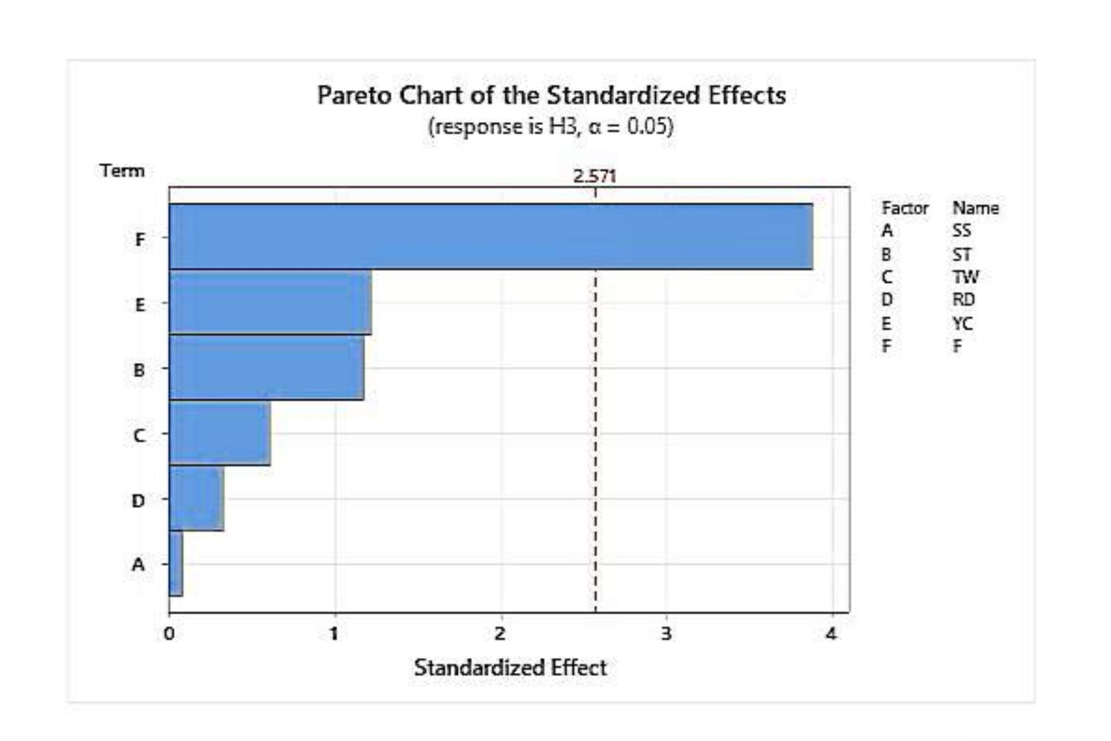
Figure 13: Pareto chart of standardized effects — response H3
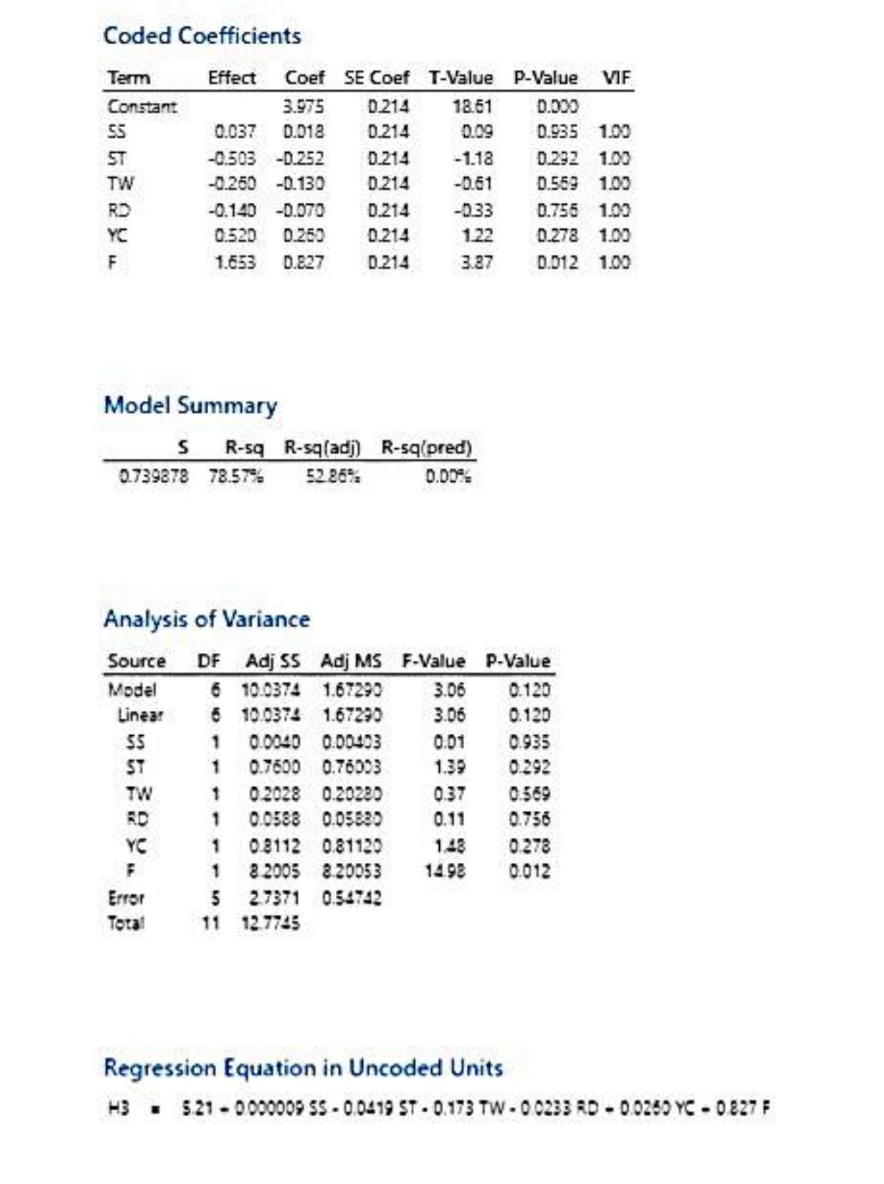
Figure 14: Coded Coefficients, Model Summary, ANOVA and Regression Equation — response H3
Model summary: S = 0.740, R-sq = 78.6%, R-sq(adj) = 52.9%. The overall model is not significant at α = 0.05 (P = 0.120), but Twist Multiplier (F) individually is (P = 0.012), accounting for 8.20 of the 10.04 model sum of squares — about 82% of the explained variation, and by far the dominant effect in this replicate.

8. Alias Structure
Because the Plackett-Burman design is Resolution III, every main effect is aliased with a specific combination of two-factor and higher-order interactions, as shown below. This structure is identical for all three replicates, since it depends only on the design matrix, not the response. This means a factor's apparent significance — such as F in replicate H3 — could, in principle, be partly due to an aliased interaction rather than a pure main effect, which is the reason a confirmatory follow-up design is recommended in Section 11.
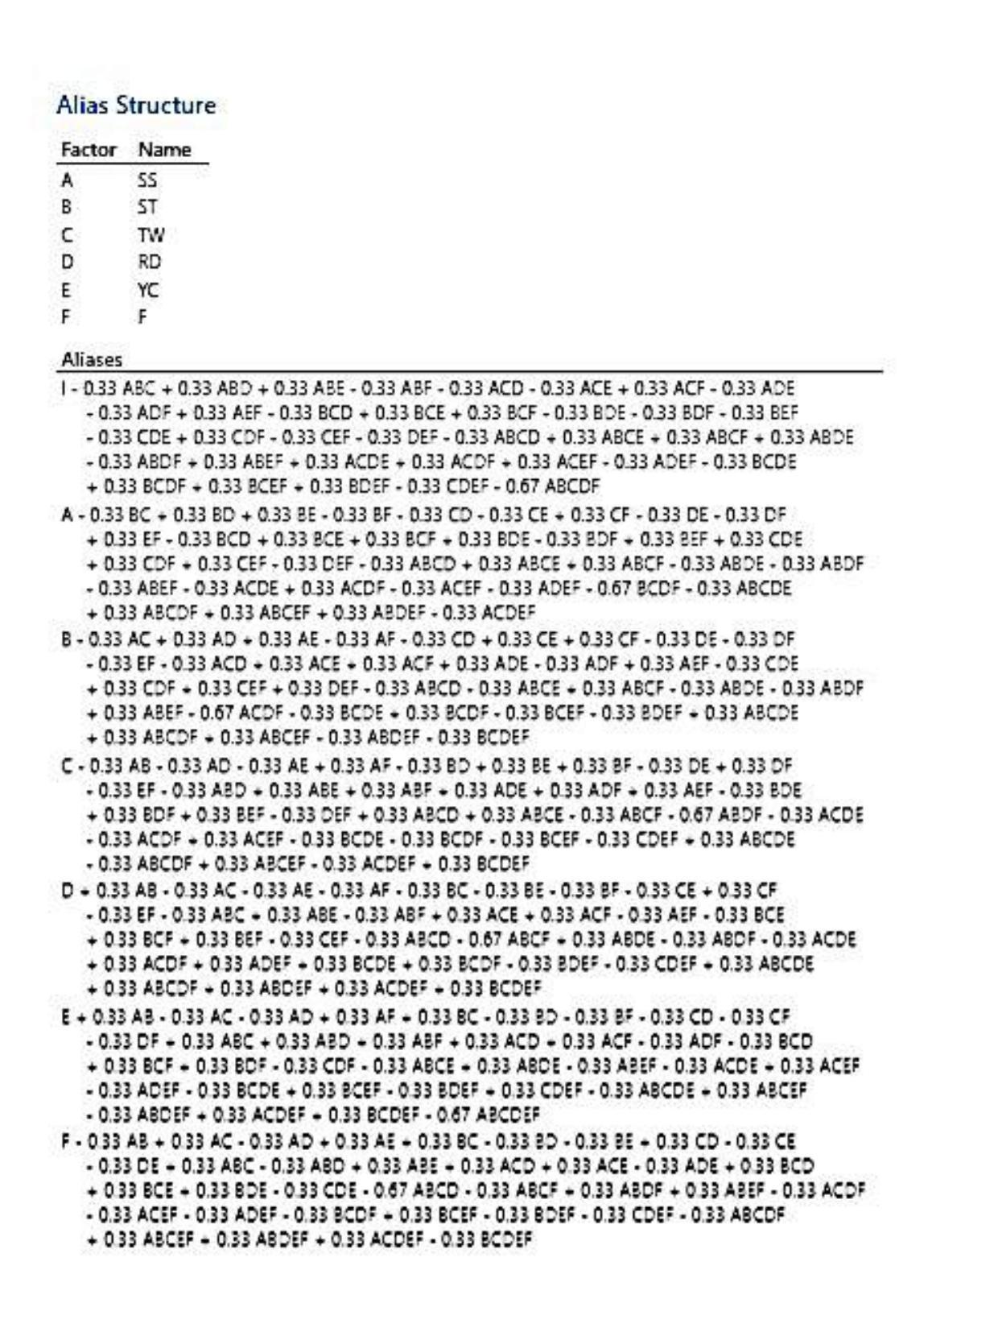
Figure 15: Alias structure for the 12-run, 6-factor Plackett–Burman design

9. Comparative Significance Across Replicates
Factor | P-value H1 | P-value H2 | P-value H3 | Lowest-P Replicate
SS (A) | 0.729 | 0.260 | 0.935 | H2
ST (B) | 0.664 | 0.409 | 0.292 | H3
TW (C) | 0.429 | 0.874 | 0.569 | H1
RD (D) | 0.532 | 0.684 | 0.756 | H1
YC (E) | 0.150 | 0.497 | 0.278 | H1
F | 0.839 | 0.429 | 0.012* | H3
*Significant at α = 0.05.
No single factor is consistently significant across all three replicates, which is expected given the Resolution III design and only 5 error degrees of freedom per model. Twist Multiplier (F) is the only factor to cross the significance threshold, and only in replicate H3. Yarn Count (E) trends strongest in H1, and Spindle Speed (A) trends strongest in H2.

10. Identification of Significant Factors
Combining the P-values, effect magnitudes and sums of squares from all three replicates, the six factors can be grouped as follows:
- Twist Multiplier (F): the only factor found statistically significant, and only in replicate H3 (P = 0.012), where it dominates the model (≈82% of explained variation).
- Spindle Speed (A) and Yarn Count (E): not significant in any replicate, but each is the strongest (lowest-P) factor in one replicate (H2 and H1 respectively) — recurring 'candidates of interest'.
- Spinning Tension (B), Traveler Weight (C), Ring Diameter (D): consistently high P-values (> 0.29) in all three replicates — the 'trivial many' that can be fixed at whichever level is most convenient for production.
Twist Multiplier, Spindle Speed and Yarn Count together emerge as the factors worth carrying forward into a confirmatory study, while Spinning Tension, Traveler Weight and Ring Diameter show negligible and inconsistent effects across replicates.

11. Recommended Follow-Up Study
Since this is a Resolution III screening design, main effects are aliased with two-factor interactions (Section 8), and results vary between replicates (Section 9). Before finalizing process settings, it is recommended to:
- Run a full 2³ factorial design, or a Response Surface / Taguchi optimization design, on Twist Multiplier, Spindle Speed and Yarn Count to obtain de-aliased, precise estimates of their main effects and interactions.
- Fix Spinning Tension, Traveler Weight and Ring Diameter at convenient mid-range production settings, since they showed consistently high P-values (low influence) across all three replicates.
- Increase the number of replicates per run (e.g., 3–5) in the follow-up study to shrink the error variance, since the current 12-run screening models explain little variance on new data (R-sq(pred) ≈ 0% throughout) and results differ noticeably between replicates.

12. Conclusion
A 12-run Plackett–Burman screening design was used to evaluate the effect of six ring-spinning process parameters on yarn Hairiness Index, with three replicate measurements (H1, H2, H3) analysed independently via Factorial Regression, ANOVA and Pareto charts. The following conclusions can be drawn:
- Twist Multiplier (F) is the only factor found statistically significant (Effect = 0.827 coded coefficient, P = 0.012), and only in replicate H3, where it explains roughly 82% of the model's variation.
- Spindle Speed (A) and Yarn Count (E) show the strongest, though not statistically significant, trends in replicates H2 (P = 0.260) and H1 (P = 0.150) respectively.
- Spinning Tension, Traveler Weight and Ring Diameter had consistently high P-values (negligible effect) across all three replicates.
- Model limitations: the saturated main-effects models achieved R-sq of 47–79% depending on the replicate, but R-sq(pred) ≈ 0% throughout, and the design's Resolution III alias structure means main effects are confounded with two-factor interactions — both expected characteristics of a 12-run screening design that should not be over-interpreted as a final predictive model.
- A focused, higher-resolution follow-up experiment on Twist Multiplier, Spindle Speed and Yarn Count is recommended to obtain de-aliased estimates and determine optimal settings for minimum yarn hairiness.
Overall, the Plackett–Burman screening design successfully reduced the experimental effort from 64 runs (full 2⁶ factorial) to just 12 runs, while still narrowing six candidate parameters down to three worth carrying forward into a focused, higher-resolution optimization study.

